**CRESCO PUBLIC LIBRARY**

**320 NORTH ELM STREET**

**CRESCO, IOWA 52136**

**Strategic Plan 2024 - 2027**

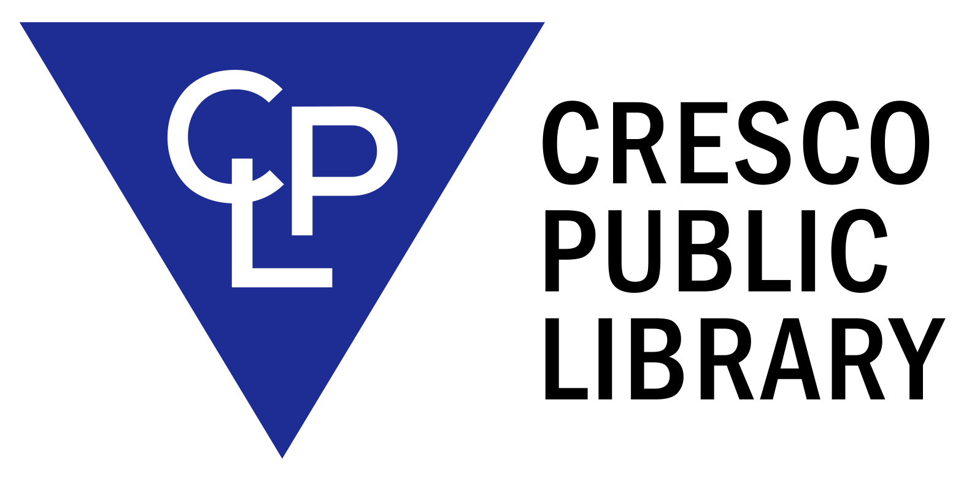

Approved by the Cresco Public Library Board of Trustees

January 17, 2024

**ROLES, MISSION STATEMENT AND GOALS AND OBJECTIVES**

**Library Roles**

PRIMARY ROLE:

POPULAR MATERIAL LIBRARY: The Library features current, high-demand, high-interest materials in a variety of formats for persons of all ages.

SECONDARY ROLES:

CHILDHOOD LEARNING: The library encourages children to develop an interest in reading and learning through services for children, and for parents and children together.

INDEPENDENT LEARNING CENTER: The library supports individuals of all ages pursuing a sustained program of learning independence.

FORMAL EDUCATION SUPPORT CENTER: The library assists students of all ages in meeting educational objectives established during their formal courses of study.

STAFF DEVELOPMENT: The Library Board of Trustees encourages the development and maintenance of library skills.

**Mission Statement**

It is the mission of the Cresco Public Library to provide free, unlimited access to its resources, ~~both~~ materials and services to meet the personal, educational, and professional needs of those in the community. Special emphasis is placed on providing popular materials in a timely manner, on providing reference services to students at all academic levels and other information seekers, and on making facilities available for local individuals, organizations, and agencies to do community work. The library serves as a learning and activities center for all residents.

**Community Analysis**

The collection of the Cresco Public Library has been developed to serve the citizens of Cresco, Howard County, and the surrounding rural areas. Cresco is located in northeast Iowa and is the county seat of Howard County. The population of Cresco is less than 4,000. Local businesses have a strong agribusiness orientation, and include some industry and a number of retail stores. The courthouse, county extension offices, a hospital, and two adult care centers are located here. In addition, the Howard-Winneshiek Community School is comprised of a preK-12 campus located in Cresco. There also exists a parochial school system comprised of Notre Dame Elementary. The Early Childhood Development Center includes preschool classrooms, Headstart, and early childhood special education. Northeast Iowa Community College has a satellite center in Cresco providing educational opportunities for people of all ages.

The following demographic information from the 2020 Census is helpful in characterizing the library’s clientele. Due to Cresco’s low population, the United States Census does not maintain data on Cresco itself. The statistics below are for Howard County, Iowa, and are used to provide the most accurate representation of the parent community of the library.

* Over 20% of Howard County residents are over the age of 65, and 25.3% of residents are under the age of 18.
* High school degrees are held by 91.2% of Howard County. Bachelor’s degrees have been earned by 18.6% of the population. There is no data on graduate or professional degrees.
* Languages other than English are spoken at home in 5.6% of the population aged 5 and up.
* The average Howard County resident travels 22.3 minutes to work for those in the workforce over the age of 16.
* A broadband internet subscription is in 79.5% of households.
* The median household income is $56,709 for Howard County.
* Howard County, Iowa has 10.5% of its population living in poverty.

**Goals and Objectives**

1. **Make Informed Decisions: Life Choices, Being and Informed Citizen, Information Literacy, and Job and Career Development,** 
   1. **Goal 1: Job Seekers will utilize library resources**

Objective 1: The Library will connect with IowaWorks to educate staff about available resources and information to assist patrons’ reference requests.

Time Frame: Completed by December 2024

Target Audience: Library Staff

Measure: : Employment related reference requests are accurately and efficiently handled by all staff rather than being directed to Jordyn decreasing technology assistance appointments outside of current programs by 50%.

Library Staff Involved: All staff members.

Objective 2: Library Staff will direct patrons to utilize library resources when faced with employment-related reference requests.

Time Frame: Completed by December 2024

Target Audience: Job seekers, students, retirees

Measure: An increase in traffic on online resources like Brainfuse Job Now/Vet Now by July 2025

Library Staff Involved: All staff members

Objective 3: The library will promote job seeking library resources through changing displays, available bookmarks, and social media to increase public’s knowledge of available resources.

Time Frame: Completed by July 2025

Target Audience: Job seekers, students, retirees

Measure: An increase on online resources like Brainfuse Job Now/Vet Now

Library Staff Involved: All staff members

* 1. **Goal 2: Patrons of Howard County and Cresco will actively participate in their civic duties.**

Objective 1: The library will provide resources and displays to encourage patrons’ civic participation, specifically in local, state, and federal elections.

Time Frame: Completed by December 2024.

Target Audience: Voters and High School Students

Measure: Increased number of votes cast in federal, local, and state elections in comparison to past years

Library Staff Involved: All staff members.

Objective 2: The library will hold informative programs about upcoming elections and voting procedures.

Time Frame: Completed by December 2024.

Target Audience: Voters and High School Students

Measure: Change in number of votes cast in federal, local, and state elections in comparison to past years.

Library Staff Involved: Jordyn.

* 1. **Goal 3: Patrons’ digital information literacy will increase.**

Objective 1: The library will hold programs discussing information literacy and digital spaces.

Time Frame: Completed by December 2025.

Target Audience: Teens and Adults

Measure: Once assisted, patrons do not return as frequently to the library for information literacy issues.

Library Staff Involved: Jordyn

Objective 2: The library will promote resources on internet safety and best practices.

Time Frame: Completed by March 2025.

Target Audience: Teens and Adults

Measure: Improved sophistication and use of public resources as measured by patron searches, questions, and requests made to library staff or through surveys.

Library Staff Involved: All library staff.

1. **Know Your Community: Community Resources and Services**
   1. **Goal 1: The library will connect with local partners to identify gaps in resources, services, and information to better serve patrons.**

Objective 1: The library will attend monthly Chamber meetings to connect with business partners.

Time Frame: Completed by March 2025.

Target Audience: Business Owners, Chamber

Measure: Attendance at Chamber meetings and new partnerships developed

Library Staff Involved: Jordyn

Objective 2: The library will host quarterly public meetings and provide a survey to gather feedback on the current services and investigate new or better services.

Time Frame: December 2026.

Target Audience: General Public

Measure: Public’s attendance at the meetings and survey respondents

Library Staff Involved: Jordyn and Roxie

Objective 3: The library will connect with local business owners to create and help promote the Summer Library Program through sponsorships.

Time Frame: Completed by December 2026.

Target Audience: Business Owners and Summer Library Program Participants

Measure: Increased number of Summer Library Program Sponsors and Business Partners

Library Staff Involved: Kim, Jordyn, Young Adult Librarian

* 1. **Goal 2: The library will be involved in the City of Cresco’s new Strategic Plan development to help address library needs while learning the City’s priorities.**

Objective 1: Participate in conversations and meetings developing the new strategic plan.

Time Frame: July 2027.

Target Audience: Library Board of Trustees, City Hall, City Council

Measure: Attendance at Strategic Plan meetings.

Library Staff Involved: Jordyn

Objective 2: Update library’s strategic plan to coincide with the City’s updated plan.

Time Frame: December 2027.

Target Audience: Library Board of Trustees and General Public

Measure: Changes to the library’s strategic plan that were inconsistent with city goals.

Library Staff Involved: Jordyn

* 1. **Goal 3: The library will increase its participation in community events to provide outreach services.**

Objective 1: Obtain a Book Bike to attend farmer’s market, the fair, ball games, and other community events

Time Frame: March 2028.

Target Audience: Children, Teens, and English Language Learners

Measure: Number and attendance of off-campus programs

Library Staff Involved: Jordyn, Kim, and Young Adult Librarian

Objective 2: Partner with city departments and organizations to better the library’s reputation and visibility in off-site events

Time Frame: July 2026

Target Audience: Non-library users and the general public

Measure: New library card sign ups and off-site program attendance

Library Staff Involved: Jordyn, Kim, and Young Adult Librarian

Mission Statement Examples:

Dyserville, Iowa:

Mission: The James Kennedy Public Library enriches the Dyersville community by providing equal access to creative resources for entertainment and education.

Vision: The James Kennedy Public Library helps create a thriving community to inspire curiosity, creativity, innovation, and connection.

Iowa City, Iowa:

Mission: The Iowa City Public Library is a center of community life that connects people of all ages with information, engages them with the world of ideas and with each other, and enriches the community by supporting learning, promoting literacy, and encouraging creativity

Cedar Falls, Iowa:

Mission: Cultivating enduring pathways to experiences that inspire, enrich and captivate the imagination.

Suggestion:

Mission: The Cresco Public Library connects its patrons with current information for entertainment and education, facilitates social interaction, promotes literacy, and inspires creativity and curiosity throughout the community.